
DEVELOPMENT NSO
Acceptance Test Procedure Document
Environment: CFS VIP 172.28.2.26 | RFS VIP 172.28.2.27 (HA Primary/Secondary)
LSA Deployment (CFS/RFS)
Cisco Network Services Orchestrator (NSO)
Revision History
Revision No. | Date of Submission | Description of Revision | Prepared By | Date of submission for Review | Review completed Date
1.0 | 07th Jul26 | Initial version |  | 07-07-2026

Prepared by | Reviewed By | Approved by

Table of Contents
1. Introduction 4
Deployment Details 4
2. Test Cases Summary 5
3. Access and System Health Verification 6
Test Case 1: Authenticating into the NSO Environment (Login) 6
Test Case 2: Verifying System Health and Runtime Status 11
4. Device Connectivity and Configuration Synchronization 18
Test Case 3: Validating Device Reachability and Sync from the CFS 18
Test Case 4: Validating Device Reachability and Sync from the RFS 24
5. Package Management 30
Test Case 5: Verifying Installed Package Status (Service Package Check) 30
Test Case 6: Package Upgrade Workflow 40

1 Introduction
This acceptance test plan documents the tests performed on the Cisco NSO (Network Services Orchestrator) platform to validate the installation, connectivity, and operational readiness of the LSA (Layered Service Architecture) deployment across the CFS (Customer Facing Service) and RFS (Resource Facing Service) layers for the T-Fiber network.
Acceptance testing included verification of user authentication and system access, platform health and runtime status, device connectivity and configuration synchronization across both the CFS and RFS layers, and the operational status of installed service packages. Additional testing was performed to verify that the NSO package directory structure remained present and consistent across all cluster nodes following the migration from Cisco NSO 5.7.3 to Cisco NSO 6.4.11. The deployment architecture was subsequently migrated from a RAFT consensus-based cluster to a High Availability (HA) design using a rule-based algorithm, with a Virtual IP (VIP) fronting each cluster: 172.28.2.26 for the CFS cluster and 172.28.2.27 for the RFS cluster. All references to RAFT cluster roles (leader/follower) in this document have been superseded by HA cluster roles (Primary/Secondary), and standard operational access is now performed through the CFS and RFS VIPs rather than by addressing individual cluster nodes directly.
Each test case documented in this plan includes the procedure followed, the expected result, and the actual outcome, supported by relevant logs and screenshots as evidence of successful validation.

Deployment Details

Environment | CFS HA Cluster - Virtual IP (VIP) 172.28.2.26 | Nodes: 172.28.2.11 (Primary), 172.28.2.12 (Secondary), 172.28.2.13 (Secondary)
RFS Node | RFS HA Cluster - Virtual IP (VIP) 172.28.2.27 | Nodes: 172.28.2.14 (Primary), 172.28.2.15 (Secondary), 172.28.2.16 (Secondary)
Cluster Nodes | CFS: cfs-node-11, cfs-node-12, cfs-node-13 (behind VIP 172.28.2.26) | RFS: rfs-node-1, rfs-node-2, rfs-node-3 (behind VIP 172.28.2.27)
Deployment Type | LSA (Layered Service Architecture) - RFS/CFS, with High Availability (HA) via Virtual IP (rule-based algorithm)

2 Test Cases Summary
The table below summarizes each verification step performed. Detailed procedure, expected result, and supporting evidence (screenshots) are documented against each test case.
# | Checkpoint | What It Confirms | Type | Result
1 | Authenticating into the NSO Environment (Login) | Authorized staff can securely authenticate and access the CFS and RFS clusters via SSH, using the CFS VIP (172.28.2.26) and RFS VIP (172.28.2.27). | CLI | PASS
2 | Verifying System Health and Runtime Status | The NSO orchestration platform is running and reachable via both VIPs, with all required modules active; HA cluster role (Primary/Secondary, rule-based algorithm) confirmed for both the CFS and RFS clusters. | CLI | PASS
3 | Validating Device Reachability and Sync from the CFS | The RFS cluster is registered on the CFS as a single device (RFS-27) addressed at the RFS VIP (172.28.2.27); it is reachable and connectable from the CFS VIP, and configuration sync (devices sync-from) succeeds via the CFS VIP, which always routes to the current HA Primary. | CLI | PASS
4 | Validating Device Reachability and Sync from the RFS | Registered field devices (190+, e.g., CGNTPOLAGPRO01) are reachable and connectable via the RFS VIP; configuration sync succeeds via the RFS VIP, which always routes to the current HA Primary, while direct access to a Secondary node correctly rejects sync-from as read-only. | CLI | PASS
5 | Verifying Installed Package Status (Service Package Check) | The installed NSO packages are correctly displayed along with an active operational status. | CLI | PASS
6 | Package Upgrade Workflow | Package directory structure is present and consistent across all CFS and RFS nodes (Primary and Secondary) following the migration to Cisco NSO 6.4.11. | CLI | PASS

3. Access and System Health Verification

These test cases are performed directly on the NSO command-line interface (CLI) and validate the platform, its connectivity, and its provisioning logic before any web-facing verification is attempted.
Test Case 1: Authenticating into the NSO Environment (Login)
Description: | Validates that an authorized user can securely authenticate and gain shell access to the NSO CFS and RFS clusters via SSH using the HA Virtual IPs, confirming that platform access controls are functioning correctly and that the VIP correctly routes the session to the current HA Primary node across all six underlying nodes.
Procedure: | 1.Launch a terminal or SSH client.  2.Connect to the Linux server using the command:  ssh root@172.28.2.26 (CFS VIP) and ssh root@172.28.2.27 (RFS VIP). The VIP always resolves to the current HA Primary node for that cluster; individual nodes (172.28.2.11-13 CFS, 172.28.2.14-16 RFS) remain separately reachable for maintenance.  3.Enter the configured password when prompted.  4.Confirm that login is successful and the shell prompt is displayed.
Expected Result: | The user should be successfully authenticated and granted access to both the CFS VIP (172.28.2.26) and RFS VIP (172.28.2.27) without any login errors. The system should display the shell prompt of whichever physical node is currently the HA Primary (e.g. root@leader-prod:~# for CFS, root@rfsleaderprod:~# for RFS), confirming that the VIP is correctly routing to the active Primary node.
Result: | ☐ OK ☐ Not OK
Logs/Snaps: (if Any) | Access via CFS Virtual IP (VIP) 172.28.2.26  image  SSH to CFS VIP 172.28.2.26: authenticated successfully. The VIP transparently routes the session to whichever CFS node is currently the HA Primary.  Access via RFS Virtual IP (VIP) 172.28.2.27  image  SSH to RFS VIP 172.28.2.27: host key accepted on first connect, authenticated successfully. The VIP transparently routes the session to whichever RFS node is currently the HA Primary.  Administrator logging into the NSO CLI via the CFS and RFS Virtual IPs. Individual physical nodes (172.28.2.11-13 for CFS, 172.28.2.14-16 for RFS) remain independently reachable via SSH for maintenance purposes, but standard operational access is now performed exclusively through the HA VIPs.  Per-Node Verification (individual cluster members)  CFS Node 1 - 172.28.2.11 (leader-prod, HA Primary)  image  ssh root@172.28.2.11: authenticated successfully, prompt root@leader-prod:~# shown.  CFS Node 2 - 172.28.2.12 (follower1-prod, HA Secondary1)  image  ssh root@172.28.2.12: authenticated successfully, prompt root@follower1-prod:~# shown.  CFS Node 3 - 172.28.2.13 (follower2-prod, HA Secondary2)  image  ssh root@172.28.2.13: authenticated successfully, prompt root@follower2-prod:~# shown.  RFS Node 1 - 172.28.2.14 (rfsleaderprod, HA Primary)  image  ssh root@172.28.2.14: host key accepted on first connect, authenticated successfully, prompt root@rfsleaderprod:~# shown.  RFS Node 2 - 172.28.2.15 (rfsfollower1prod, HA Secondary1)  image  ssh root@172.28.2.15: host key accepted, authenticated successfully, prompt root@rfsfollower1prod:~# shown.  RFS Node 3 - 172.28.2.16 (rfsfollower2prod, HA Secondary2)  image  ssh root@172.28.2.16: host key accepted, authenticated successfully, prompt root@rfsfollower2prod:~# shown.  All six underlying physical nodes remain individually reachable via SSH on their own IPs (172.28.2.11-13 CFS, 172.28.2.14-16 RFS), confirming platform access controls at the node level in addition to VIP-level access above.

Test Case 2: Verifying System Health and Runtime Status
Description: | Validates that the Cisco NSO orchestration engine is running correctly on the CFS and RFS clusters by confirming key runtime parameters including NSO version, daemon PID, active modules, HA cluster role (Primary/Secondary, rule-based algorithm), configuration file location, installation directory, and runtime directory are all reported without error when accessed via the CFS and RFS VIPs.
Procedure: | 1. Access the Linux shell/CLI via the CFS VIP (172.28.2.26) and RFS VIP (172.28.2.27).  2. Execute the command: ncs --status (using the full binary path /home/nso/nso-6.4/bin/ncs --status where the ncs binary is not yet on PATH).  3. Review the output for NSO version, daemon state, running modules, process ID, HA cluster status (mode: primary/secondary, node id, connected secondaries), configuration file, installation directory, and runtime directory. Also review the High Availability page in the Crosswork NSO WebUI, which shows the running/configured HA role of every node in the cluster in a single view.  4. Confirm that the NSO status is displayed as started and all required modules are running on each node.
Expected Result: | The command should successfully display the NSO runtime details on every node. The NSO status should be started, the daemon process should be running with a valid PID, the configured modules (backplane, netconf, cdb, cli, snmp, webui) should be active, and the HA cluster status should show exactly one node in primary mode per cluster with the remaining nodes connected as secondary.
Result: | ☐ OK ☐ Not OK
Logs/Snaps: (if Any) | HA Cluster Status - Crosswork NSO WebUI (High Availability page)  image  CFS HA status via WebUI (172.28.2.26:8080/webui-one/HighAvailability): High availability is enabled using the rule-based algorithm. cfs-node-11 is running as primary (configured as primary, marked "current"); cfs-node-12 and cfs-node-13 are running as secondary (configured as secondary).  ncs --status via CFS VIP 172.28.2.26  image  CFS VIP 172.28.2.26 - ncs --status: vsn 6.4.11, status: started, all modules (backplane, netconf, cdb, cli, snmp, webui) running, daemon pid reported. cluster status: mode: primary, node id: cfs-node-11, connected secondaries: 2.  ncs --status via RFS VIP 172.28.2.27  image  RFS VIP 172.28.2.27 - ncs --status: vsn 6.4.11, status: started, all modules running. cluster status: mode: primary, node id: rfs-node-1, connected secondaries: 2.  NSO status check confirming the platform is running and the HA cluster (rule-based algorithm) reports exactly one Primary per cluster, with the remaining nodes connected as Secondary, on both the CFS and RFS clusters.  Per-Node Verification (individual cluster members)  CFS Node 1 - 172.28.2.11 (leader-prod, HA Primary)  image  ncs --status: vsn 6.4.11, status: started, all required modules running, daemon PID reported. Node-level HA role: primary.  CFS Node 2 - 172.28.2.12 (follower1-prod, HA Secondary1)  image  ncs --status: status: started, all required modules running. Node-level HA role: secondary, connected to primary (172.28.2.11).  CFS Node 3 - 172.28.2.13 (follower2-prod, HA Secondary2)  image  ncs --status: status: started, all required modules running. Node-level HA role: secondary, connected to primary (172.28.2.11).  RFS Node 1 - 172.28.2.14 (rfsleaderprod, HA Primary)  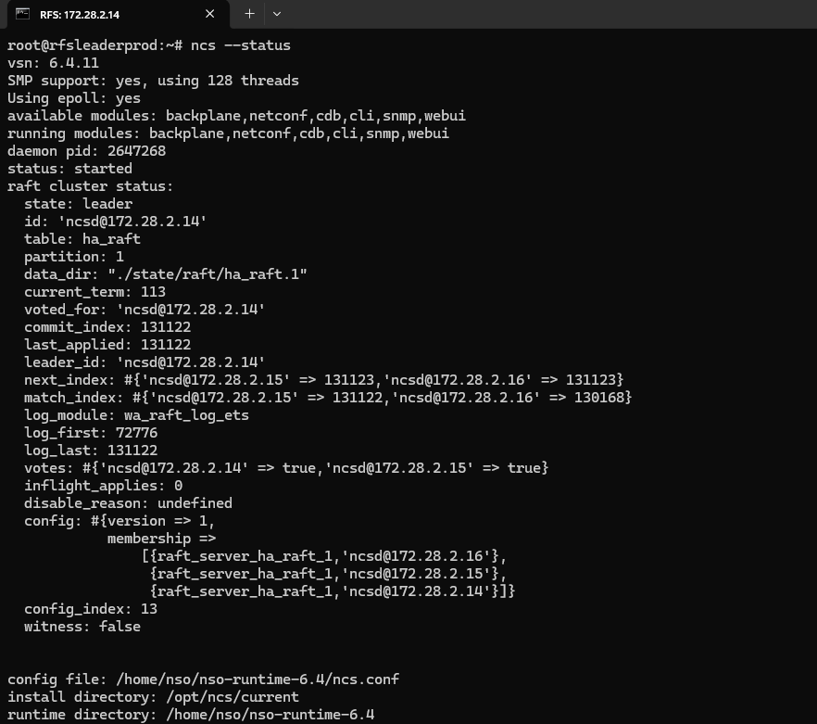  ncs --status: status: started, all required modules running. Node-level HA role: primary.  RFS Node 2 - 172.28.2.15 (rfsfollower1prod, HA Secondary1)  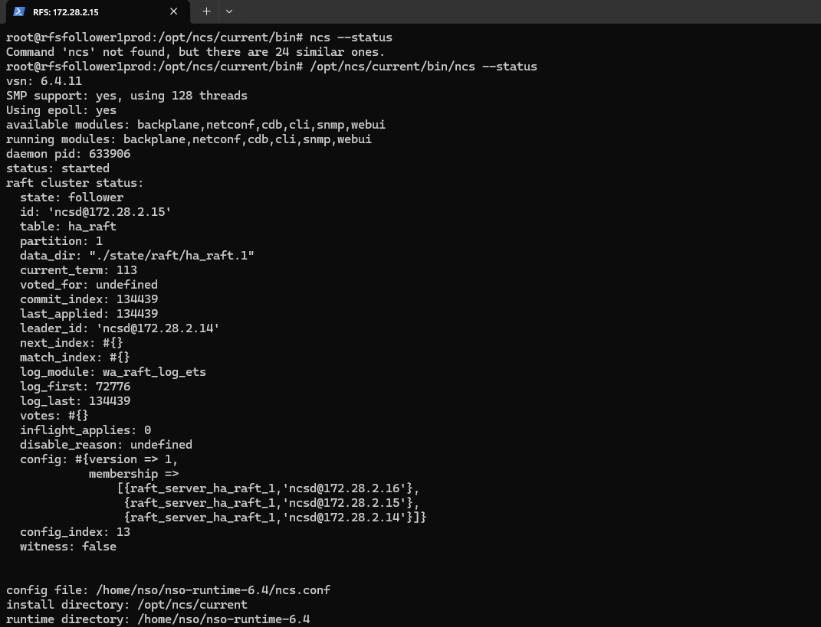  ncs --status: status: started, all required modules running. Node-level HA role: secondary, connected to primary (172.28.2.14).  RFS Node 3 - 172.28.2.16 (rfsfollower2prod, HA Secondary2)  image  ncs --status: status: started; the NSO daemon itself remained up, though HA replication to this node briefly reported an exception during the capture window (transient - not a sustained fault). Node-level HA role: secondary.  Individual node status confirms the NSO daemon is started on every one of the six physical nodes, with HA role (primary/secondary) reported consistently with the cluster-wide VIP-level view shown above.

4. Device Connectivity and Configuration Synchronization
Test Case 3: Validating Device Reachability and Sync from the CFS
Description: | Verifying end-to-end device handling in Cisco NSO from the CFS cluster: confirming the RFS cluster is registered as a single device (RFS-27) addressed at the RFS VIP, verifying connectivity from the CFS VIP, and confirming that configuration sync (devices sync-from) succeeds via the CFS VIP, which always routes to the current HA Primary.
Procedure: | 1.Run show devices list via the CFS VIP (172.28.2.26) to confirm the device RFS-27 (172.28.2.27, the RFS VIP) is registered and unlocked. Also confirm the same device is visible in the Devices page of the Crosswork NSO WebUI at 172.28.2.26:8080.  2.Execute devices device RFS-27 connect via the CFS VIP to validate reachability and establish a session with the RFS VIP.  3.Perform devices sync-from via the CFS VIP to pull the live configuration from RFS-27 into NSO, and confirm the sync completes successfully. Because the VIP always routes to the current HA Primary, the sync is expected to succeed consistently, without needing to test individual physical node roles.
Expected Result: | The device RFS-27 appears in the list with the correct address (172.28.2.27) and NED ID, on both the CLI and the WebUI, when accessed via the CFS VIP.  The connection attempt via the CFS VIP returns result true with confirmation of successful connectivity to RFS-27 (172.28.2.27:2022).  Because the CFS VIP always routes to the current HA Primary, and only the Primary may write to the CDB, devices sync-from via the CFS VIP is expected to return result true. Direct write access to a Secondary node (bypassing the VIP) is still correctly rejected with info "node is in read-only mode" - this is normal CFS HA behavior, not a fault.
Result: | ☐ OK ☐ Not OK
Logs/Snaps: (if Any) | Devices page - Crosswork NSO WebUI (CFS VIP)  image  CFS VIP 172.28.2.26:8080/webui-one/Devices: Device management shows a single registered device, RFS-27, at address 172.28.2.27 (the RFS VIP), port 2022.  show devices list (CFS VIP)  image  CFS VIP 172.28.2.26 - show devices list: device RFS-27, address 172.28.2.27, NED ID cisco-nso-nc-6.4, admin state unlocked.  devices device RFS-27 connect (CFS VIP)  image  CFS VIP 172.28.2.26 - devices device RFS-27 connect: result true, info "Connected to RFS-27 - 172.28.2.27:2022".  devices sync-from (CFS VIP)  image  CFS VIP 172.28.2.26 - devices sync-from: sync-result { device RFS-27, result true }.  Device connectivity and configuration sync confirmed end-to-end from the CFS VIP to the RFS VIP. Because the VIP always routes to the current HA Primary, sync-from succeeds consistently without needing to test individual node roles; failover to a Secondary is handled transparently by the HA layer.  Per-Node Verification (individual cluster members, prior device model)  CFS Node 1 - 172.28.2.11 (leader-prod, HA Primary)  image  show devices list: rfs-node-1 (172.28.2.14), rfs-node-2 (172.28.2.15), rfs-node-3 (172.28.2.16), NED cisco-nso-nc-6.4, all unlocked.  image  devices device connect for rfs-node-1/2/3: result true for all three, e.g. "Connected to rfs-node-1 - 172.28.2.14:2022".  image  devices sync-from: sync-result true for rfs-node-1, rfs-node-2, and rfs-node-3.  CFS Node 2 - 172.28.2.12 (follower1-prod, HA Secondary1)  image  show devices list: same three rfs-node devices, all unlocked.  image  devices device connect for rfs-node-1/2/3: result true for all three.  image  devices sync-from: result false for all three devices, info "node is in read-only mode" (expected - only the HA Primary may write).  CFS Node 3 - 172.28.2.13 (follower2-prod, HA Secondary2)  image  show devices list: same three rfs-node devices, all unlocked.  image  devices device connect for rfs-node-1/2/3: result true for all three.  image  devices sync-from: result false for all three devices, info "node is in read-only mode" (expected, same reason as Secondary1).  This per-node evidence was captured under the prior device model, in which the CFS registered each RFS node individually (rfs-node-1/2/3). It is retained to show node-level read/write behavior under HA. Current provisioning uses the single RFS-27 device via the RFS VIP shown above, which is reachable and writable through any CFS node because the VIP always resolves to whichever node is the current HA Primary.

Test Case 4: Validating Device Reachability and Sync from the RFS
Description: | Validating device connectivity and configuration synchronization in Cisco NSO from the RFS cluster against the real field network devices (GPON/access nodes). This confirms that registered field devices can be reached, connected, and their live configurations synchronized into NSO's internal database, and that sync writes are correctly restricted to the RFS HA Primary (accessed via the RFS VIP 172.28.2.27).
Procedure: | 1.Run show devices list to confirm the registered field devices (e.g., ADBICDAXMAR001, ADGDGOVIGPRO01, AKPTAKKAGPRO01, ALDRALLAGPRO01, ADVPADAVGPRO01, CGNTPOLAGPRO01 and other GPON/access devices - 190+ devices in total) are registered and unlocked.  2.From the RFS HA Primary (172.28.2.14), reached via the RFS VIP (172.28.2.27), execute devices device <name> connect for a representative device to validate reachability and establish a session.  Example: devices device CGNTPOLAGPRO01 connect  3.From the RFS HA Primary (via the RFS VIP), perform devices device <name> sync-from (and a bulk devices sync-from) to pull the live configuration into NSO.  Example: devices device CGNTPOLAGPRO01 sync-from  4.Repeat show devices list and devices sync-from directly against each RFS Secondary node (172.28.2.15, 172.28.2.16, bypassing the VIP) to confirm read-only behavior is correctly enforced.
Expected Result: | 1.Devices appear in the list with correct addresses, NED IDs, and admin states set to unlocked.  2.From the RFS HA Primary (via the RFS VIP), the connection attempt returns result true with confirmation of successful connectivity (e.g., "Connected to CGNTPOLAGPRO01 - 172.16.1.123:22"), and sync-from returns result true.  3.From RFS Secondary nodes (direct access, bypassing the VIP), sync-from is expected to return result false with info "node is in read-only mode" for each device - normal RFS HA behavior, since only the Primary may write to the CDB.
Result: | ☐ OK ☐ Not OK
Logs/Snaps: (if Any) | image show devices list from RFS VIP (field devices)  RFS 172.28.2.14 (Primary, via RFS VIP 172.28.2.27) - show devices list: 190+ field devices registered (e.g., ADBICDAXMAR001 - 10.253.192.107, ADGDGOVIGPRO01 - 172.16.128.20, AKPTAKKAGPRO01 - 172.16.2.227), NED cisco-ios-cli-6.113, all unlocked.  image  RFS 172.28.2.14 (Primary, via RFS VIP) - devices device CGNTPOLAGPRO01 connect: result true, "Connected to CGNTPOLAGPRO01 - 172.16.1.123:22".  image  RFS 172.28.2.14 (Primary, via RFS VIP) - devices device CGNTPOLAGPRO01 sync-from: result true.  image  RFS 172.28.2.15 (Secondary1) - show devices list: same full 190+ device inventory, all unlocked.  devices sync-from from RFS Secondary1 (read-only)  image  RFS 172.28.2.15 (Secondary1) - devices sync-from (bulk, all devices): result false for each device, info "node is in read-only mode".  image  RFS 172.28.2.15 (Secondary1) - devices sync-from continued: result false / "node is in read-only mode" for devices including CGNTRUKMGPR01, CGNTWADIGPR01, CHKRRAMAGPR01, CHPLTHEEGPR01, CHPRMALKGPR01, CMRGADLOGPR01, CMRGDONDGPR01, CMRGKISTGPR01, CNBVBEKKGPR01, CNBVDAGAGPR01 (expected - only the RFS HA Primary may write).  Show devices list from RFS 16  image  RFS 172.28.2.16 (Secondary2) - show devices list: same full 190+ device inventory, all unlocked.  devices sync-from from RFS 16  image  image  RFS 172.28.2.16 (Secondary2) - devices sync-from (bulk, all devices): command issued. || RFS 172.28.2.16 (follower2) - devices sync-from result: result false / "node is in read-only mode" for each device (same sample as Secondary1), expected for a non-primary (Secondary) node.  Device connectivity list confirming reachable network devices.

5. Package Management
Test Case 5: Verifying Installed Package Status (Service Package Check)
Description: | Verify that the installed NSO packages are displayed along with their operational status
Procedure: | Execute the command: show packages package oper-status  - Review the list of installed packages displayed in the output.  - Verify the package names and their operational status.  - Confirm that the package operational status information is displayed for all listed packages.
Expected Result: | The command should display the list of installed packages along with an operational status of "up" for every package, on every CFS and RFS node.
Result: | ☐ OK ☐ Not OK
Logs/Snaps: (if Any) | image  CFS 172.28.2.11 (Primary, via CFS VIP 172.28.2.26) - show packages package oper-status (part 1 of 2): bgp, ciena-mcp-gen-1.9, cisco-ios-cli-6.113, cisco-iosxr-cli-7.75, cisco-nso-nc-6.4, dudm-rfs, interface-ill, ip-route, l2-vfi, l2vpn-pw, l2vpn-service, loopback, mpls-l2vpn - all oper-status up.  image  CFS 172.28.2.11 (Primary, via CFS VIP 172.28.2.26) - show packages package oper-status (part 2 of 2): multi-service-cfs, nokia-apc, nokia-apc-gen-1.0, ospf, prefix-set, qos, rfs-ned, route-map, route-map-pass-all, route-policy, routing-protocol, tejas-nms, tejas-nms-cfs, tejas-nms-nso, tejas-nms5500-gen-1.0, tfiber-common, tfiber-interface, vrf - all oper-status up.  image CFS 172.28.2.12 (Secondary1) - show packages package oper-status (part 1 of 2): same CFS package set, all oper-status up.  image  CFS 172.28.2.12 (Secondary1) - show packages package oper-status (part 2 of 2): same CFS package set, all oper-status up.  image  CFS 172.28.2.13 (Secondary2) - show packages package oper-status (part 1 of 2): same CFS package set, all oper-status up.  image  CFS 172.28.2.13 (Secondary2) - show packages package oper-status (part 2 of 2): same CFS package set, all oper-status up.  image  RFS 172.28.2.14 (Primary, via RFS VIP 172.28.2.27) - show packages package oper-status (part 1 of 2): alu-isam-cli-1.5, bgp, ciena-mcp-gen-1.9, cisco-ios-cli-6.113, cisco-iosxr-cli-7.75, dudm-rfs, interface-ill, ip-route, l2-vfi, l2vpn-pw, l2vpn-service, loopback, mpls-l2vpn, mpls-l3vpn, nokia-apc, nokia-apc-gen-1.0, ospf, prefix-set, qos, route-map - all oper-status up.  image  RFS 172.28.2.14 (Primary, via RFS VIP 172.28.2.27) - show packages package oper-status (part 2 of 2): route-map-pass-all, route-policy, routing-protocol, tejas-nms, tejas-nms-modify, tejas-nms-nso, tejas-nms5500-gen-1.0, tfiber-common, tfiber-interface, vrf - all oper-status up.  image  RFS 172.28.2.15 (Secondary1) - show packages package oper-status: full RFS package set, all oper-status up.  image  RFS 172.28.2.16 (Secondary2) - show packages package oper-status: full RFS package set, all oper-status up.  Service package operational status — confirmed active.

Test Case 6: Package Upgrade Workflow
Description: | Verify that the NSO package directory structure is present and consistent across all CFS and RFS cluster nodes (Primary and Secondary, behind the CFS VIP 172.28.2.26 and RFS VIP 172.28.2.27 respectively) following the migration to Cisco NSO 6.4.11.
Procedure: | Procedure:  - On each CFS node (172.28.2.11 leader-prod / Primary, 172.28.2.12 follower1-prod / Secondary1, 172.28.2.13 follower2-prod / Secondary2), navigate to the NSO packages directory:  - cd /home/nso/nso-6.4/packages  - Verify that all required package directories are present:  - ls -ltr  - On each RFS node (172.28.2.14 rfsleaderprod / Primary, 172.28.2.15 rfsfollower1prod / Secondary1, 172.28.2.16 rfsfollower2prod / Secondary2), navigate to the NSO home/runtime directory (or filesystem root) and run:  - ls -ltr  - Note: the evidence captured for this test case consists only of the directory-listing checks above. No screenshot evidence was found for a package compile (make clean all) or packages reload step, so those steps are not represented as verified here.
Expected Result: | - The package directories (tools, lsa, auth) are present and identical on all three CFS nodes.  - The corresponding runtime files/folders are present on all three RFS nodes.  - No missing or unexpected directory entries are observed on any node.
Result: | ☐ OK ☐ Not OK
Logs/Snaps: (if Any) | Package directory listing (ls -ltr)  image  image  image  CFS 172.28.2.11 (leader-prod / Primary) - ls -ltr in /home/nso/nso-6.4/packages: directories tools, lsa, auth present (dated Feb 19, 13:27). || CFS 172.28.2.12 (follower1-prod / Secondary1) - ls -ltr in /home/nso/nso-6.4/packages: identical tools, lsa, auth directories present. || CFS 172.28.2.13 (follower2-prod / Secondary2) - ls -ltr in /home/nso/nso-6.4/packages: identical tools, lsa, auth directories present.  image  image  RFS 172.28.2.14 (rfsleaderprod / Primary) - ls -ltr in /home/nso/nso-6.4: etc directory present || RFS 172.28.2.15 (rfsfollower1prod / Secondary1) - ls -ltr in /: standard root filesystem listing (bin, boot, dev, etc, home, lib, opt, proc, root, run, snap, srv, sys, usr, var), confirming filesystem intact.  image  RFS 172.28.2.16 (rfsfollower2prod / Secondary2) - ls -ltr in home directory: snap directory only (dated Apr 10, 14:32).

